Assignment 1

### **1 New Customers Acquired in June 2023**

**Business Problem:**  
The marketing team ran a campaign in June 2023 and wants to see how many new customers signed up during that period.

**Fields to Retrieve:**

* PARTY_ID
* FIRST_NAME
* LAST_NAME
* EMAIL
* PHONE
* ENTRY_DATE

select p.PARTY_ID, p.FIRST_NAME, p.LAST_NAME, cm.INFO_STRING as Email, tn.CONTACT_NUMBER as Phone, pt.CREATED_DATE as Entry_Date

from person p

join party pt on p.PARTY_ID = pt.PARTY_ID

join party_role pr on pr.PARTY_ID=pt.PARTY_ID And pr.ROLE_TYPE_ID='Customer'

join party_contact_mech pcm on pcm.PARTY_ID=p.PARTY_ID

join contact_mech cm on cm.CONTACT_MECH_ID=pcm.CONTACT_MECH_ID

join telecom_number tn on tn.CONTACT_MECH_ID=cm.CONTACT_MECH_ID

where pt.CREATED_DATE between '2023-06-01' and '2023-06-30';

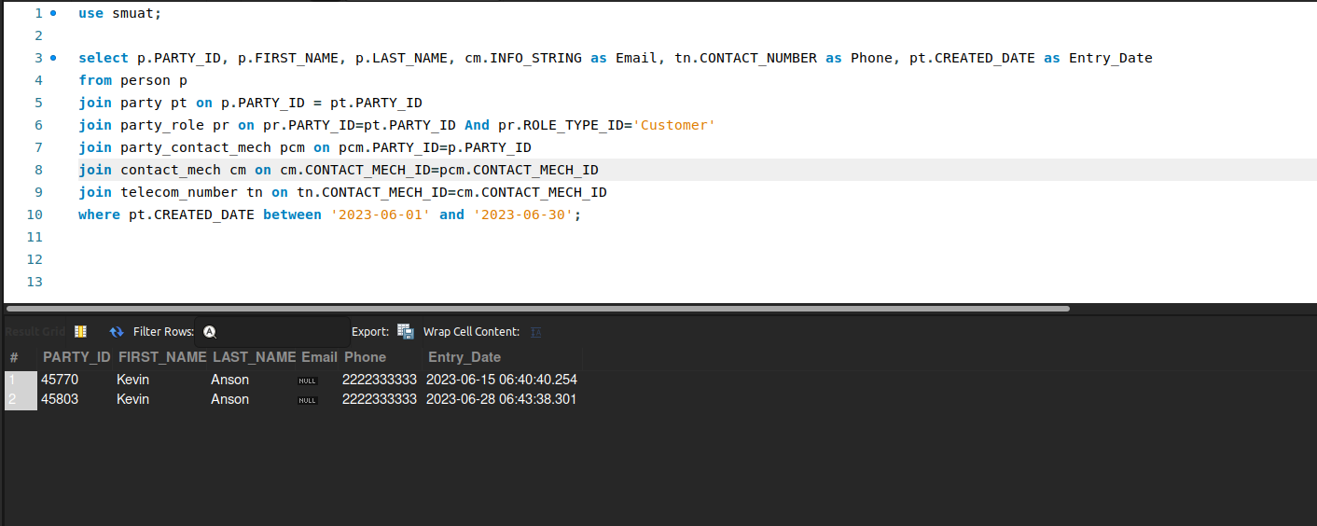

### **2 List All Active Physical Products**

**Business Problem:**  
Merchandising teams often need a list of all physical products to manage logistics, warehousing, and shipping.

**Fields to Retrieve:**

* PRODUCT_ID
* PRODUCT_TYPE_ID
* INTERNAL_NAME

select p.PRODUCT_ID, p.PRODUCT_TYPE_ID, p.INTERNAL_NAME

from product p

join product_type pt on p.PRODUCT_TYPE_ID=pt.PRODUCT_TYPE_ID

where pt.IS_PHYSICAL='Y';

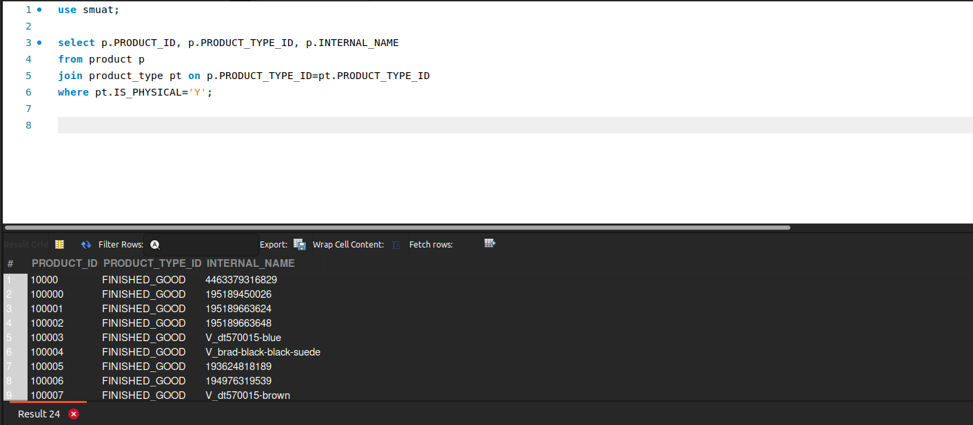

### **3 Products Missing NetSuite ID**

**Business Problem:**  
A product cannot sync to NetSuite unless it has a valid NetSuite ID. The OMS needs a list of all products that still need to be created or updated in NetSuite.

**Fields to Retrieve:**

* PRODUCT_ID
* INTERNAL_NAME
* PRODUCT_TYPE_ID
* NETSUITE_ID (or similar field indicating the NetSuite ID; may be NULL or empty if missing)

select p.PRODUCT_ID, p.PRODUCT_TYPE_ID, p.INTERNAL_NAME, gi.GOOD_IDENTIFICATION_TYPE_ID as NetSuite_ID

from product p

join good_identification gi on gi.PRODUCT_ID=p.PRODUCT_ID

where gi.GOOD_IDENTIFICATION_TYPE_ID='ERP_ID'

And gi.ID_VALUE is null;

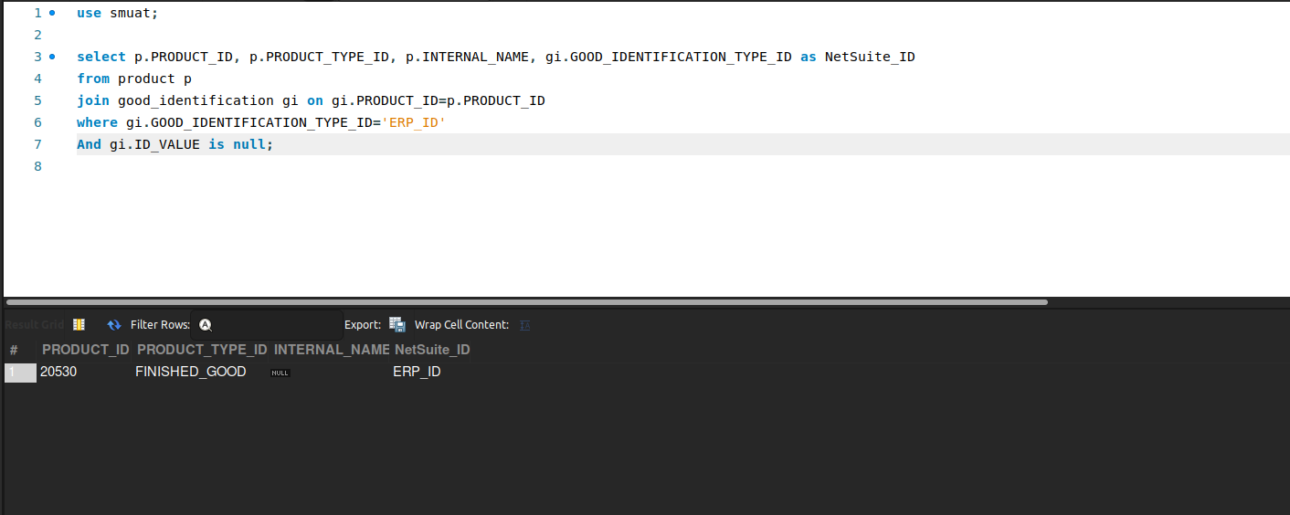

### **4 Product IDs Across Systems**

**Business Problem:**  
To sync an order or product across multiple systems (e.g., Shopify, HotWax, ERP/NetSuite), the OMS needs to know each system’s unique identifier for that product. This query retrieves the Shopify ID, HotWax ID, and ERP ID (NetSuite ID) for all products.

**Fields to Retrieve:**

* PRODUCT_ID (internal OMS ID)
* SHOPIFY_ID
* HOTWAX_ID
* ERP_ID or NETSUITE_ID (depending on naming)

select p.PRODUCT_ID, sp.SHOPIFY_PRODUCT_ID,p.PRODUCT_ID as HotWax_Id, gi.GOOD_IDENTIFICATION_TYPE_ID as Netsuite_Id

from product p

join shopify_product sp on sp.product_id=p.product_id

join good_identification gi on gi.PRODUCT_ID=p.PRODUCT_ID

where gi.GOOD_IDENTIFICATION_TYPE_ID='ERP_ID';

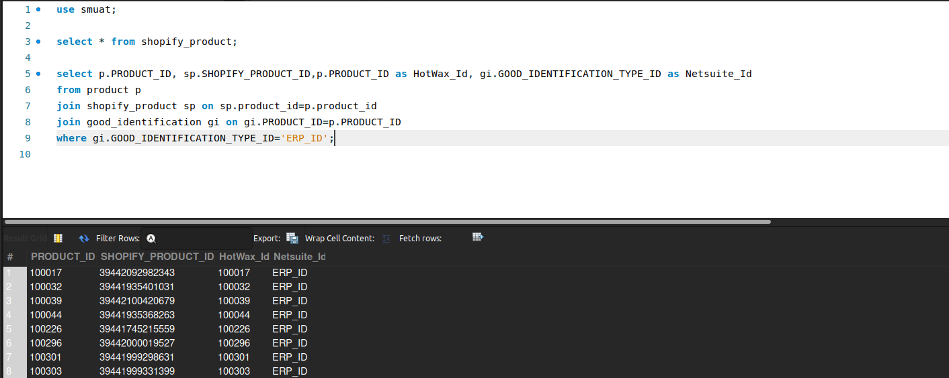

### **5 Completed Orders in August 2023**

**Business Problem:**  
After running similar reports for a previous month, you now need all completed orders in August 2023 for analysis.

**Fields to Retrieve:**

* PRODUCT_ID
* PRODUCT_TYPE_ID
* PRODUCT_STORE_ID
* TOTAL_QUANTITY
* INTERNAL_NAME
* FACILITY_ID
* EXTERNAL_ID
* FACILITY_TYPE_ID
* ORDER_HISTORY_ID
* ORDER_ID
* ORDER_ITEM_SEQ_ID
* SHIP_GROUP_SEQ_ID

select oh.ORDER_ID, p.PRODUCT_ID, p.PRODUCT_TYPE_ID,

oh.PRODUCT_STORE_ID,sum(oi.QUANTITY) as Total_Quantity,p.INTERNAL_NAME,

oi.SHIP_GROUP_SEQ_ID,oi.ORDER_ITEM_SEQ_ID,f.FACILITY_TYPE_ID,oh.ORIGIN_FACILITY_ID, odh.ORDER_HISTORY_ID

from order_header oh

join order_item oi on oi.ORDER_ID=oh.ORDER_ID

join product p on p.product_id=oi.PRODUCT_ID

join facility f on f.facility_id=oh.ORIGIN_FACILITY_ID

join order_history odh on odh.ORDER_ID=oh.ORDER_ID

where oh.STATUS_ID='ORDER_COMPLETED' AND oh.ORDER_DATE BETWEEN '2023-08-01' AND '2023-08-31'

group by oh.ORDER_ID,

p.PRODUCT_ID,

p.PRODUCT_TYPE_ID,

oh.PRODUCT_STORE_ID,

p.INTERNAL_NAME,

oi.SHIP_GROUP_SEQ_ID,

oi.ORDER_ITEM_SEQ_ID,

f.FACILITY_TYPE_ID,

oh.ORIGIN_FACILITY_ID,

odh.ORDER_HISTORY_ID;

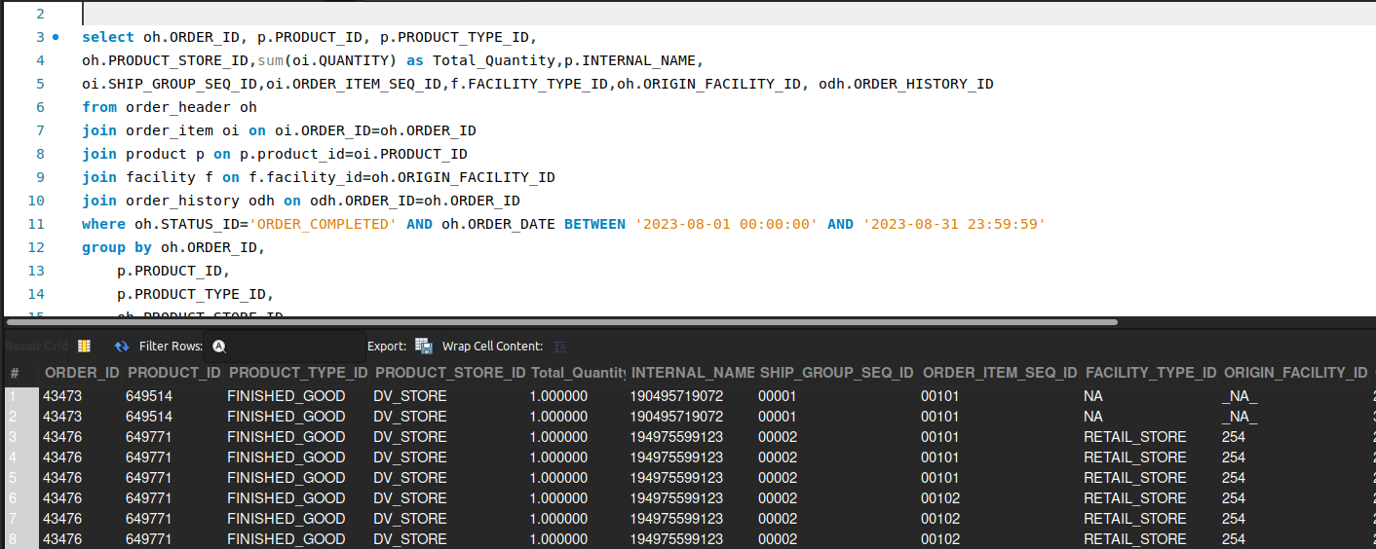

### **7 Newly Created Sales Orders and Payment Methods**

**Business Problem:**  
Finance teams need to see new orders and their payment methods for reconciliation and fraud checks.

**Fields to Retrieve:**

* ORDER_ID
* TOTAL_AMOUNT
* PAYMENT_METHOD
* Shopify Order ID (if applicable)

select oh.order_id, oh.GRAND_TOTAL as TOTAL_AMOUNT, opp.PAYMENT_METHOD_TYPE_ID as PAYMENT_METHOD,

oh.EXTERNAL_ID as Shopify_Order_ID

from order_header oh

join order_payment_preference opp on oh.ORDER_ID=opp.ORDER_ID

where oh.ORDER_DATE between '2023-08-01' and '2023-08-31';

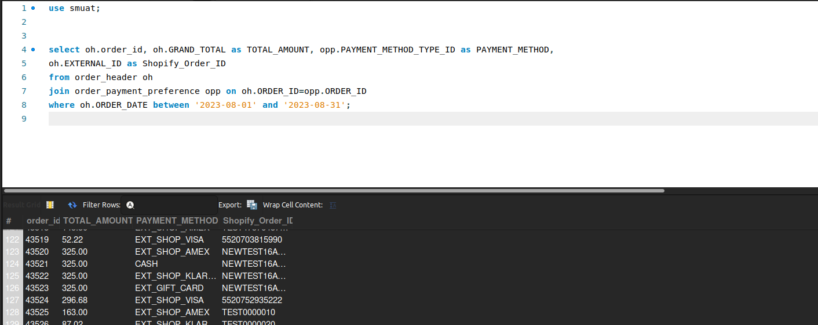

### **8 Payment Captured but Not Shipped**

**Business Problem:**  
Finance teams want to ensure revenue is recognized properly. If payment is captured but no shipment has occurred, it warrants further review.

**Fields to Retrieve:**

* ORDER_ID
* ORDER_STATUS
* PAYMENT_STATUS
* SHIPMENT_STATUS

select oh.ORDER_ID, oh.STATUS_ID as Order_Status, opp.STATUS_ID as Payment_Status, sh.STATUS_ID as Shipment_Status

from order_header oh

join order_payment_preference opp on oh.ORDER_ID=opp.order_Id

join order_shipment os on oh.ORDER_ID=os.ORDER_ID

join shipment sh on os.SHIPMENT_ID=sh.SHIPMENT_ID

where opp.STATUS_ID='PAYMENT_SETTLED' and sh.STATUS_ID!='SHIPMENT_SHIPPED';

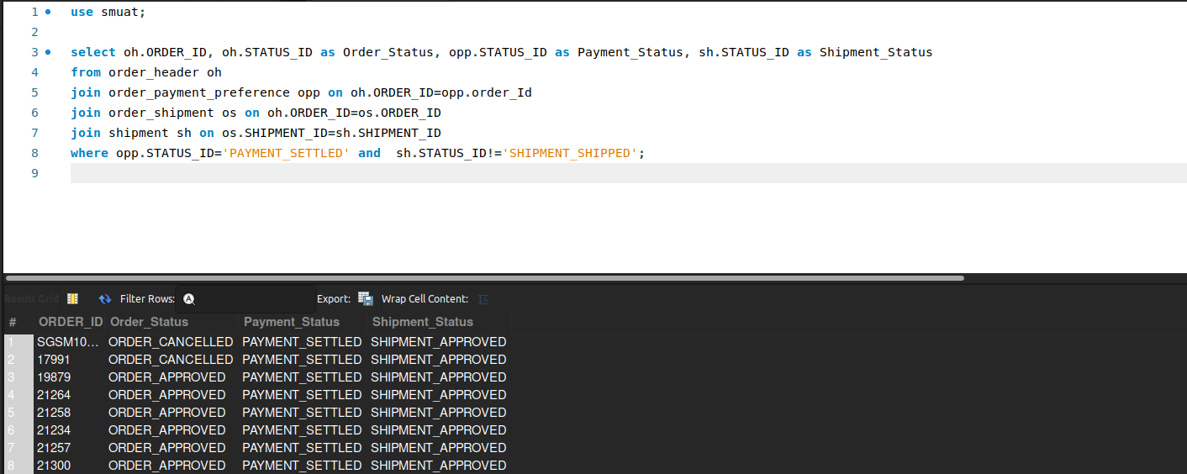

### **9 Orders Completed Hourly**

**Business Problem:**  
Operations teams may want to see how orders complete across the day to schedule staffing.

**Fields to Retrieve:**

* TOTAL ORDERS
* HOUR

select count(oh.ORDER_ID) as Total_Order, hour(os.status_datetime) as hours

from order_header oh

join order_status os on os.order_id=oh.order_id

where os.STATUS_ID='Order_Completed'

group by hours;

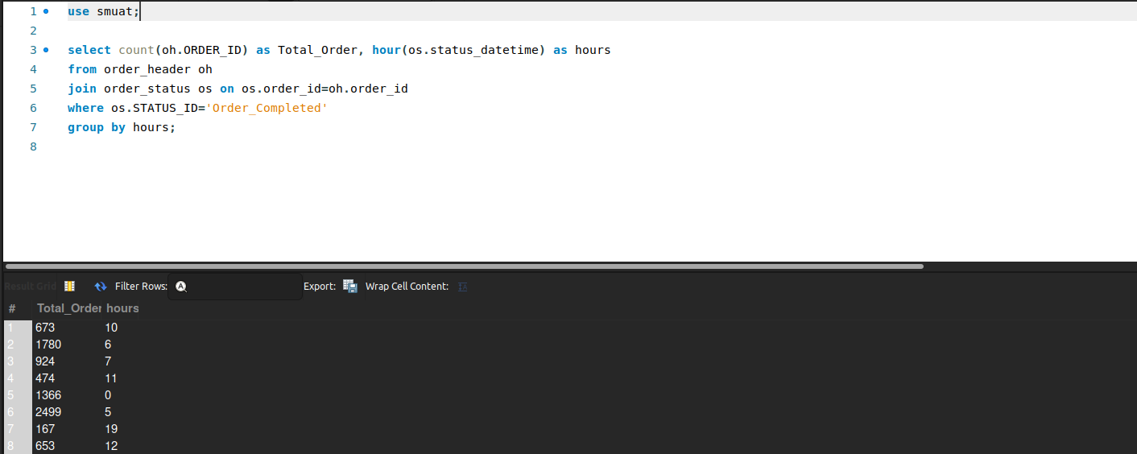

### **10 BOPIS Orders Revenue (Last Year)**

**Business Problem:**  
**BOPIS** (Buy Online, Pickup In Store) is a key retail strategy. Finance wants to know the revenue from BOPIS orders for the previous year.

**Fields to Retrieve:**

* TOTAL ORDERS
* TOTAL REVENUE

select sum(oh.GRAND_TOTAL) as Total_Revenue, count(oh.ORDER_ID) as Total_Orders

from order_header oh

join order_item_ship_group oisg on oisg.ORDER_ID=oh.ORDER_ID

where oisg.SHIPMENT_METHOD_TYPE_ID='storepickup'

and year(oh.ORDER_DATE) = year(CURDATE()) - 1;

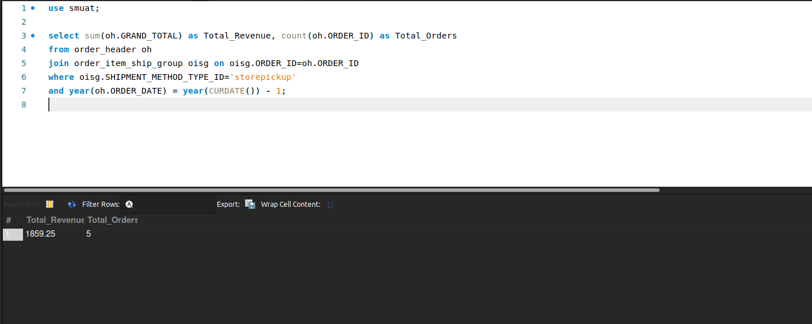

### **11 Canceled Orders (Last Month)**

**Business Problem:**  
The merchandising team needs to know how many orders were canceled in the previous month and their reasons.

**Fields to Retrieve:**

* TOTAL ORDERS
* CANCELATION REASON

select count(distinct oh.order_id) as Total_Orders, os.CHANGE_REASON as Cancelation_Reason

from order_header oh

join order_status os on oh.ORDER_ID=os.ORDER_ID

where oh.STATUS_ID='ORDER_CANCELLED'

AND os.STATUS_DATETIME >= DATE_FORMAT(CURDATE() - INTERVAL 1 MONTH, '22-%m-01')

AND os.STATUS_DATETIME < DATE_FORMAT(CURDATE(), '22-%m-01')

group by os.CHANGE_REASON;

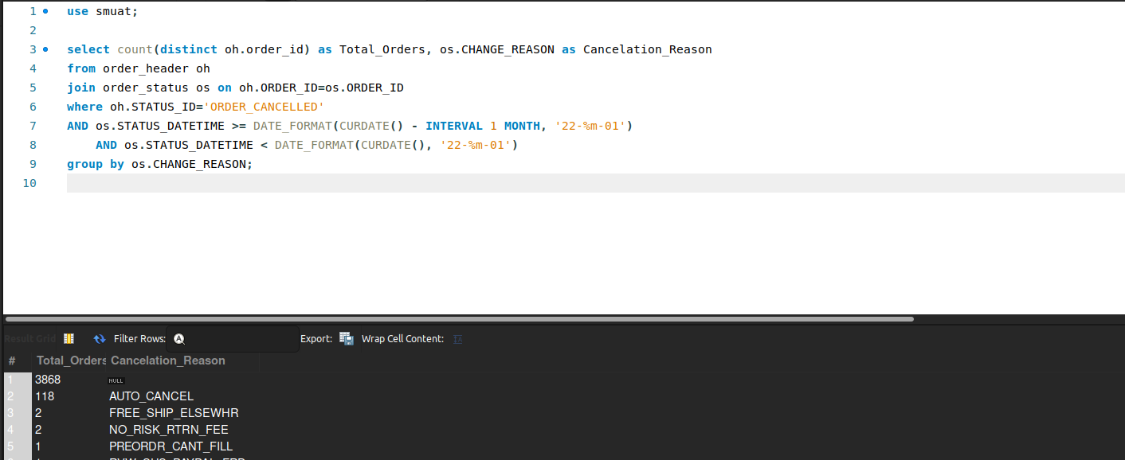

### **12 Product Threshold Value**

**Business Problem** The retailer has set a threshild value for products that are sold online, in order to avoid over selling.

**Fields to Retrieve:**

* PRODUCT ID
* THRESHOLD

select PRODUCT_STORE_ID, REPLENISH_THRESHOLD from product_store_fin_act_setting;

